**Aim:** Practical based on NumPy ndarray

**IDE:**

NumPy is a Python package created in 2005 that performs numerical calculations. It is generally used for working with arrays. NumPy also includes a wide range of mathematical functions, such as linear algebra, Fourier transforms, and random number generation, which can be applied to arrays.

Import NumPy in Python

We can import NumPy in Python using the import statement.

import numpy as np

The code above imports the numpy package in our program as an alias np. After this import statement, we can use NumPy functions and objects by calling them with np.

**NumPy Array Creation**

An array allows us to store a collection of multiple values in a single data structure. The NumPy array is similar to a list, but with added benefits such as being faster and more memory efficient. There are multiple techniques to generate arrays in NumPy.

**Create Array Using Python List**

We can create a NumPy array using a Python List. For example,

Example

import numpy as np

list1 = [2, 4, 6, 8]

array1 = np.array(list1)

print(array1)

Output

Example

import numpy as np

array1 = np.array([2, 4, 6, 8])

print(array1)

Output

Create an Array Using np.zeros()

The np.zeros() function allows us to create an array filled with all zeros. For example,

Example

import numpy as np

array1 = np.zeros(4)

print(array1)

Output

Create an Array With np.arange()

The np.arange() function returns an array with values within a specified interval. For example,

Example

import numpy as np

# create an array with values from 0 to 4

array1 = np.arange(5)

print("Using np.arange(5):", array1)

# create an array with values from 1 to 8 with a step of 2

array2 = np.arange(1, 9, 2)

print("Using np.arange(1, 9, 2):",array2)

Output

Create an Array With np.random.rand()

The np.random.rand() function is used to create an array of random numbers. Let's see an example to create an array of **5** random numbers,

Example

import numpy as np

# generate an array of 5 random numbers

array1 = np.random.rand(5)

print(array1)

Output

Taks:

import numpy as np

# Example 1: Creation of 1D array

arr1=np.array([10,20,30])

print("My 1D array:\n",arr1)

Output

# Example 2: Create a 2D numpy array

arr2 = np.array([[10,20,30],[40,50,60]])

print("My 2D numpy array:\n", arr2)

Output

# Example 3: Create a sequence of integers

# from 0 to 20 with steps of 3

arr= np.arange(0, 20, 3)

print ("A sequential array with steps of 3:\n", arr)

Output

# Example 4: Create a sequence of 5 values in range 0 to 3

arr= np.linspace(0, 3, 5)

print ("A sequential array with 5 values between 0 and 5:\n", arr)

Output

# Example 5: Use ones() create array

arr = np.ones((2,3))

print("numpy array:\n", arr)

print("Type:", type(arr))

Output

NumPy Data Types

A data type is a way to specify the type of data that will be stored in an array. For example,

array1 = np.array([2, 4, 6])

**NumPy Data Types**

NumPy offers a wider range of numerical data types than what is available in Python. Here's the list of most commonly used numeric data types in NumPy:

1. int8, int16, int32, int64 - signed integer types with different bit sizes
2. uint8, uint16, uint32, uint64 - unsigned integer types with different bit sizes
3. float32, float64 - floating-point types with different precision levels
4. complex64, complex128 - complex number types with different precision levels

Check Data Type of a NumPy Array

import numpy as np

# create an array of integers

int_array = np.array([-3, -1, 0, 1])

# create an array of floating-point numbers

float_array = np.array([0.1, 0.2, 0.3])

# create an array of complex numbers

complex_array = np.array([1+2j, 2+3j, 3+4j])

# check the data type of int_array

print(int_array.dtype) # prints int64

# check the data type of float_array

print(float_array.dtype) # prints float64

# check the data type of complex_array

print(complex_array.dtype) # prints complex128

Output

Creating NumPy Arrays With a Defined Data Type

In NumPy, we can create an array with a defined data type by passing the dtype parameter while calling the np.array() function. For example,

import numpy as np

# create an array of 8-bit integers

array1 = np.array([1, 3, 7], dtype='int8')

# create an array of unsigned 16-bit integers

array2 = np.array([2, 4, 6], dtype='uint16')

# create an array of 32-bit floating-point numbers

array3 = np.array([1.2, 2.3, 3.4], dtype='float32')

# create an array of 64-bit complex numbers

array4 = np.array([1+2j, 2+3j, 3+4j], dtype='complex64')

# print the arrays and their data types

print(array1, array1.dtype)

print(array2, array2.dtype)

print(array3, array3.dtype)

print(array4, array4.dtype)

Output

**NumPy Type Conversion**

In NumPy, we can convert the data type of an array using the astype() method. For example,

import numpy as np

# create an array of integers

int_array = np.array([1, 3, 5, 7])

# convert data type of int_array to float

float_array = int_array.astype('float')

# print the arrays and their data types

print(int_array, int_array.dtype)

print(float_array, float_array.dtype)

Output

NumPy Array Attributes

In NumPy, attributes are properties of NumPy arrays that provide information about the array's shape, size, data type, dimension, and so on.

**Common NumPy Attributes**

Here are some of the commonly used NumPy attributes:

|  |  |
| --- | --- |
| Attributes | Description |
| ndim | returns number of dimension of the array |
| size | returns number of elements in the array |
| dtype | returns data type of elements in the array |
| shape | returns the size of the array in each dimension. |
| itemsize | returns the size (in bytes) of each elements in the array |
| data | returns the buffer containing actual elements of the array in memory |

The ndim attribute returns the number of dimensions in the numpy array. For example,

import numpy as np

# create a 2-D array

array1 = np.array([[2, 4, 6],

[1, 3, 5]])

# check the dimension of array1

print(array1.ndim)

Output

NumPy Array size Attribute

The size attribute returns the total number of elements in the given array.

import numpy as np

array1 = np.array([[1, 2, 3],

[6, 7, 8]])

# return total number of elements in array1

print(array1.size)

Output

NumPy Array shape Attribute

In NumPy, the shape attribute returns a tuple of integers that gives the size of the array in each dimension. For example,

import numpy as np

array1 = np.array([[1, 2, 3],

[6, 7, 8]])

# return a tuple that gives size of array in each dimension

print(array1.shape)

Output

NumPy Array dtype Attribute

We can use the dtype attribute to check the datatype of a NumPy array. For example,

import numpy as np

# create an array of integers

array1 = np.array([6, 7, 8])

# check the data type of array1

print(array1.dtype)

Output

NumPy Array itemsize Attribute

In NumPy, the itemsize attribute determines size (in bytes) of each element in the array. For example,

import numpy as np

# create a default 1-D array of integers

array1 = np.array([6, 7, 8, 10, 13])

# create a 1-D array of 32-bit integers

array2 = np.array([6, 7, 8, 10, 13], dtype=np.int32)

# use of itemsize to determine size of each array element of array1 and array2

print(array1.itemsize) # prints 8

print(array2.itemsize) # prints 4

Output

NumPy Array data Attribute

In NumPy, we can get a buffer containing actual elements of the array in memory using the data attribute.

In simpler terms, the data attribute is like a pointer to the memory location where the array's data is stored in the computer's memory.

import numpy as np

array1 = np.array([6, 7, 8])

array2 = np.array([[1, 2, 3],

[6, 7, 8]])

# print memory address of array1's and array2's data

print("\nData of array1 is: ",array1.data)

print("Data of array2 is: ",array2.data)

Task

Multiplication of two given matrixes

import numpy as np

p = [[1, 0], [0, 1]]

q = [[1, 2], [3, 4]]

print("Original matrices:")

print(p)

print(q)

# Perform matrix multiplication using np.dot

result1 = np.dot(p, q)

print("Result of the matrix multiplication:")

print(result1)

Output

Compute the determinant of a given square array.

import numpy as np

from numpy import linalg as LA

a = np.array([[1, 0], [1, 2]])

# Display the original 2x2 array 'a'

print("Original 2-d array")

print(a)

print("Determinant of the said 2-D array:")

print(np.linalg.det(a))

Output

**Post Lab Exercise:**

1. Write a NumPy program to create a 3x3 matrix with values ranging from 2 to 10.

1. Write a NumPy program to reverse an array (the first element becomes the last).

1. Write a NumPy program to find common values between two arrays.

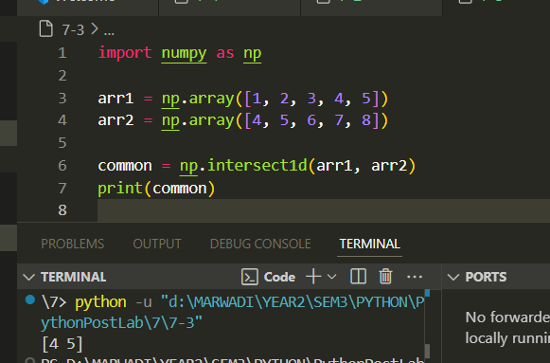

1. Write a NumPy program to repeat array elements.

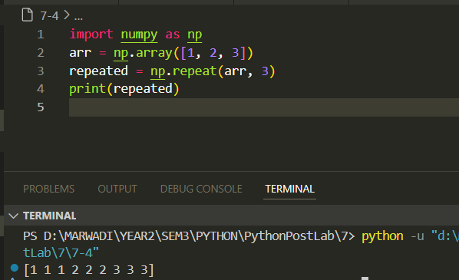

1. Write a NumPy program to find the memory size of a NumPy array.

1. Write a NumPy program to create an array of ones and zeros.

1. Write a NumPy program to find the 4th element of a specified array.

**Github :** [**PythonPostLab/7 at main · Om-Lathigara/PythonPostLab**](https://github.com/Om-Lathigara/PythonPostLab/tree/main/7)